3.49: The range for a projectile that lands at the same height from which it was launched is 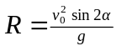. Assuming 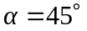, and 

